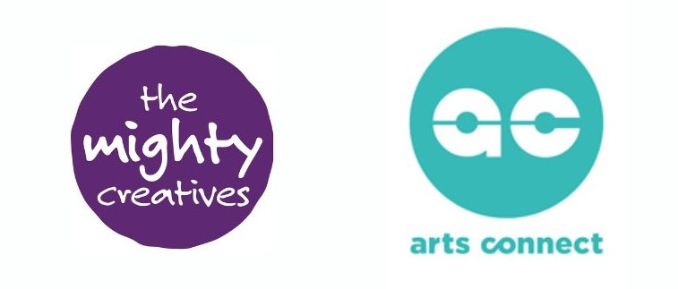

FAQs for Cultural Organisations
What is the partnership project?
It is an 18-month learning, research and development programme designed to deepen the evidence base in response to the question “How do we best engage care experienced children and young people with arts and culture?”
What difference might it make?
We work from the assumption that there is much more that needs to be done and improved. The aim is to build our collective understanding, supported by evidence, of how we address the different dimensions of the problem from a systemic point of view. So, for instance, what training is needed for people who work with care experienced children and young people? What are the benefits of different models of engagement? How do we enable care experienced children and young people to influence what is provided or offered to them? What is needed to develop learning partnerships between professionals from different sectors who have different ways of working, skills and perspectives?
We want to honour the trailblazing work of the Virtual Schools (VSs) and the many cultural organisations in the Midlands. We want to position ourselves to be able to exert a national influence and to share approaches that can be adopted in other areas. We are working towards a region that has a critical mass of experience, deep partnerships, an agile approach to funding and the knowledge to embed arts and cultural entitlement for children and young people.
What else will or might this lead to?
We’ll produce a toolkit for other VS and cultural organisations to support their development, this will structure the knowledge and lessons from the project supported with lived examples, in an engaging and approachable way.
We’d like to end up with a suite of evidenced based project proposals that are ‘ready to go’ to access funding and lead to scale up.
We hope that this will inspire new thinking in VS and cultural organisations about how they might work differently, having developed new possibilities and partnerships, with care experienced children and young people’s ideas and voices central to this process.
We are also interested in how learning might be applied to VS work with mainstream schools to enable them to be better able to meet the creative and cultural development of care experienced children and young people.
How is all this going to happen?
Over time and at a pace to enable learning and reflection through an action research process.
Firstly, we want to identify the cultural partners that want to develop their work with care experienced children and young people. Twenty-five organisations will be invited to take part in training in May 2024, preparing them for working with care experienced children and young people so that they know they have a secure level of knowledge and insight. The sessions will include trauma informed practice, working with care experienced young people, safeguarding and engaging young people’s voice. At the same time, we will ask VS what it is they would like to find out more about in relation to the core research question “How do we best engage care experienced children and young people with arts and culture?” and any additional key issues for their service.
After the professional development training programme, we will match up to 10 VS with 10 arts and cultural partners who have shown an interest in taking part in the action-research partnership project. We will invite all partners to a two-day session on 3 and 4 July 2024 (a day in Leicester and a day in Wolverhampton) to activate the partnerships. Each partnership will develop their own enquiry question, plan how they will work together and get ready to get started.
The action-research projects will take place over autumn and spring 2025 (with regular check-ins, training and support sessions across the cohort) to bring the learning together for sharing in summer of 2025.
An external evaluator will support us in understanding the learning and impact of the project.
What is Action Research?
It is an approach to investigating a problem and seeking to solve it at the same time, so conducting research and taking action. It is typically undertaken in the social sciences and education and enables the knowledge to be generated by those who are closest to the practice.
What Is Action Research? | Definition & Examples (scribbr.co.uk)
Our colleagues from the University of Wolverhampton’s Institute for Community Development and Research will provide the training and support.
What do you mean by the cultural sector?
We use the definition of Arts Council England (ACE) “The cultural sector is a term used to cover the wide range of organisations and individuals that work in dance, literature, museums, music, visual arts, combined arts and libraries.”
Why is it happening now?
Colleagues at the ACE office in the Midlands have been closely engaged with the development of the work with care experienced children and young people for many years. ACE provided the funds that have been invested by Arts Connect and The Mighty Creatives since 2015 into the regional developments such as My Creative Track, Creative Mentoring, The Artsmark Pilot for VS and establishing the Arts Ambassadors programme in the West Midlands. Furthering this work is regional priority for ACE and they approached us (Arts Connect, The Mighty Creatives and the West Midlands CIC Foundation) as organisations with established connections to propose a project model that would meet their brief for this strategic project.
What resources are involved?
The grant from ACE covers project staff and delivery costs for Arts Connect and The Mighty Creatives and also training and venue costs, so it is free to all participants. There will be a budget available for each of the 10 action research projects of up to £3,300 to pay for the costs of the project – for instance artist time, travel, visits, resources, planning. We expect that all partners will bring other resources to the project and we are keen to connect it with existing activity to make resource go as far as possible.
How are care experienced children and young people involved?
We’ll ask each partnership to think about the most appropriate, practical and powerful way to engage with the views and ideas of care experienced children and young people, according to the focus of your enquiry.
What is the timeline?
We anticipate training and partnership development will happen during the summer this year and projects will run across the academic year 24-25 with ongoing points for sharing and collaboration.
What support will be offered to partnerships?
Once matched, the cultural organisations and VS will come together for two days of orientation. During these two days, it will be decided on how we will come together throughout the programme. We want this to be informed by you, your needs and your capacity. For example, we may decide to have termly group catch ups, connect with clusters within each region, or put on themed ‘surgery style’ meetings that are shaped around specific areas.
There will of course be ongoing support from TMC and Arts Connect and the wider cohort.
How will the programme be evaluated?
TMC and Arts Connect will be working with our internal teams to collect evaluation and monitoring – however this will be very light touch (surveys etc) as we know how busy you are. It’s important to note, we aren’t looking for quantity of numbers here. We are looking for you to build your learning and to explore what is important to you and your partnership.
Arts Council England will also be commissioning an external evaluator to work with us on the programme, and what their involvement looks like is still to be decided by ACE.
What is a Virtual School?
A Virtual School (VS) is a statutory service based within every Local Authority that exist to promote high aspirations for children and young people under the care of the Local Authority (LA). They do not exist in real terms or as a building. Children and young people do not attend it, they still remain the responsibility of the school they’re enrolled at. The Virtual School is simply an organisation created for the effective co-ordination of education services at a strategic and operational level.
Every care experienced child/young person will be registered with a Virtual School and each Virtual School works very differently.
What does ‘care experienced’ mean?
Care experienced refers to any child or young person who is currently in the care of their Local Authority (for example, living in foster care, residential homes or secure units etc). It can also refer to children and young people who have a lived experience of the care system (for example, they may have returned home to their birth family, have left care at the age of 18 and are now living independently or who have been adopted).
Can I be part of the training programme but not the action-research partnership project?
Yes. We hope that in attending the training programme your organisation feels inspired to take the next step in your journey. However, we understand that every organisation is at a different stage.
If at the end of the training, you feel you cannot commit to a longer partnership project, then that is absolutely fine. However, we can support you with building connections to the VS that you may wish to work with so you can develop that relationship.
Can I be part of the action-research partnership project without attending the professional development training programme?
No. All organisations on the project have to attend the training sessions. This is to ensure that everyone has the same level of knowledge prior to starting to work in partnership.

