
Creative Mentor
Supporting Information

The Creative Mentor Role and Responsibilities

This document explains more about what will be required in this role and what you need to know if you wish to apply. If you are successful in becoming Creative Mentor, you will receive an Induction Pack with more information to support you in your work.

Please note that the formal process is designed to ensure that the opportunity is open and equal to all. We are passionate about forming a diverse pool of mentors that represents the Children and Young People that we work with, therefore we welcome applications from under-represented communities. We hope you will find it of interest, and we look forward to receiving your application to be involved in this pioneering work and to make a difference to the lives of children and young people in and leaving care.

What is Creative Mentoring and how does it work?

Creative Mentoring, is an award winning one-to-one approach to working with children and young people who are experiencing vulnerabilities and/or disadvantage. The majority of the children and young people we work with are care experienced or have a Social Worker for other needs, however we also work with children and young people at risk of offending, who are engaged in mental health services or who are struggling to engage in education, for example.

Creative Mentoring aims to develop a child or young person’s sense of self, purpose, belonging and broadening a world of opportunities through the creative practice of a Creative Mentor.

When a child or young person is disengaged and so resistant to support, where professionals are struggling to improve the situation, a Creative Mentor can be commissioned to work 1:1 with the young person.

Creative Mentors work in the Third Space as shown in the following illustration, working to help the child or young person have more self-confidence, increased social competence and improved resilience, so that they can positively reengage in learning.

See diagram below.

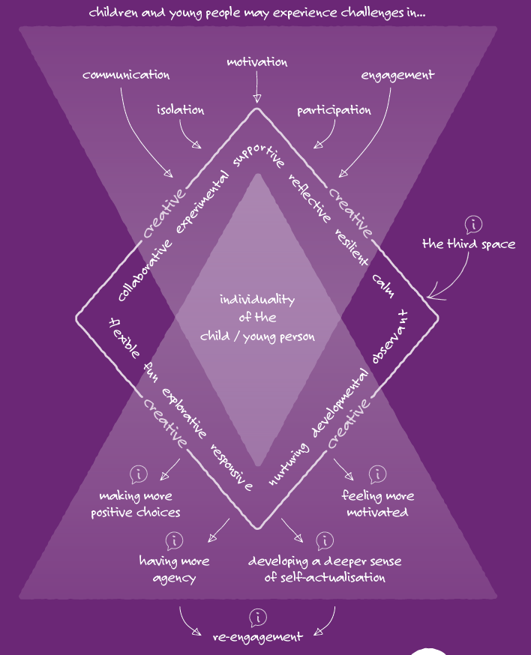

Activity in the Third Space is informal, creative and often playful. Briefed jointly by referral partners, social care professionals, supporting adults and schools, the Creative Mentor refocuses efforts away from ‘negative behaviour’, to identify what it is the child/young person needs to help them become ‘unstuck’.

The Creative Mentor takes time to get to know the child/young person and creative activity is introduced. The means of working with the child or young person is always practical, using the interests of the Child or Young Person to inform the activity. These activities can include but are not limited to Music, Poetry, Photography, practical Building and Making, etc. The aim is to help young people safely explore the world around them, learn new skills, communicate with others and address personal and emotional issues through Creativity..

Activity takes place at home, school or in the community over varying lengths of time, dependent on what specific needs are identified by the referral partner or the Child or Young Person themselves.. The Creative Mentor may even decide to learn new skills themselves to support the child/young person and encourage other supporting adults to get involved too. Learning together has proved to be a powerful way to build stronger relationships.

Through planning activity collaboratively with the child/young person alongside their supporting adults, Creative Mentors help to identify personalised pathways for progression. They encourage young people’s social and emotional development, enabling them to develop their interests, engage fully in learning and focus on their personal and educational ambitions.

What is the aim of Creative Mentoring?
The majority of Creative Mentoring referrals come from Virtual Schools across the East and West Midlands, with other referrals received from other Local Authority teams, schools or community organisations.
Virtual Schools are working in partnership with Local Authorities and schools. Together they are accountable to the Department for Education for how they use the allocation of their Pupil Premium Plus (PP+) budget that they receive for every child in care/in need. Much of it goes directly to schools to enable support for individual pupils, whose needs have been identified through Personal Education Planning (PEP) meetings. However, where a child/young person is at risk of exclusion, schools are increasingly looking to the Local Authorities, Virtual Schools and their partners for new ways to work with their students to help them find motivation and build confidence. Consequently, Creative Mentors are working very successfully in schools, modelling personalised creative approaches.

For those children/young people who are not attending school, PP+ is a means with which to fund opportunities for learning out of school and steer them back towards engagement in education with the support of Creative Mentors.

Whether they work inside or outside school, Creative Mentors become involved as part of the core team of professionals working collaboratively and creatively to support the young person socially, emotionally, educationally and practically to enable progression.

At The Mighty Creatives, we also receive referrals from a variety of other partners, including but not limited to:

- Individual Primary and Secondary Schools
- Colleges
- Community Organisations
- NHS Trusts
- Prevent Services
- Pupil Referral Units
- Alternative Education Providers
- Hospital Schools
- Youth Justice Teams

Supporting Personal Education Plans (PEPs) and Other Meetings

Every child in care has a termly PEP meeting. This meeting involves the key supporting adults and might include Parents, Foster Carer, Teacher, Social Worker and any other adult with a significant role and ideally the young person. Young people post 16 to age 18 have a Personal Education and Training Plan (PETP) meeting at least once a year.

During the time that you are working as Creative Mentor you may be involved in PEP or PETP meetings either in person or a written update and will receive an invitation via local authority partners to do so. Your allocated time can be used flexibly to enable you to attend, perhaps supporting the young person to get the most out of the PEP experience.

There may be different meetings dependent on the status of the child/young person, including Leaving Care Meetings, Child in Need Meetings and Child Protection meetings, that may also discuss the Creative Mentoring intervention.

Measuring the Impact of Creative Mentoring

Creative Mentoring is a unique programme that recognises the value of creative practice at the very front line of education improvement, to enable more disadvantaged pupils to make progress. For those who are struggling with education, the barriers are likely to include social and emotional factors. A developed set of indicators called the 10 Measures of Progress help Creative Mentors create opportunities for young people to develop their skills:

Measuring Progress

See below for our 10 Measures of Progress:

- Participation and Engagement: The ability to try something new and take part..

- Communication: The ability to talk and communicate with others positively.

- Self-Belief: Confidence in myself, who I am, my abilities and my ideas

- Teamwork – Ability to work with others.

- Relationship Building: Ability to start and maintain positive friendships and relationships with adults, family, peers, and professionals.

- Motivation: The ability to work towards completing something even when it might be hard.

- Creativity: Confidence in being creative and developing new creative skills

- Resilience: Ability to problem solve and recover from difficulties and challenges

- Emotional Wellbeing: Feeling positive about my life and my future

- Agency: Confidence to share my thoughts, feelings, and the self-belief to make change/s

Creative Mentors offer highly personalised, creative support through non-prescriptive activity in agreement with the child/young person. Although the work depends on a high level of spontaneity, spotting opportunities to build on small sparks of interest.

The Mighty Creatives requires Creative Mentors to report on their work and show how it is enabling progress for the young person.

Referrals and Reporting 

The Mighty Creatives receives referrals for Creative Mentors through our Creative Mentoring portal, completed by Local Authority partners, individual schools, alternative provision settings or residential homes.

The desired outcomes of Creative Mentoring relate to one or more of the 10 Measures of Progress which, guided by the child/young person, are baseline scored at the start of the work, i.e., 1 (yet to demonstrate this skill) to 10 (always demonstrates this skill). This helps the Creative Mentor to identify areas of strength and weakness.

After the first meeting with the child/young person, Creative Mentors will plan each session with a clear idea of how activity/reflective dialogue will achieve the specific progress outcome for the child/young person. After each session Creative Mentors will consider whether they have observed any impact, expected or otherwise, that can help them plan the next session and build on progress. This will be recorded as a brief narrative on an Activity Report/Session report.

To do this the 10 Measures of Progress (known as the Participant Skills Assessment) will be completed periodically on the portal, to assess the child’s progress, so that over time it can be cited as evidence of the impact Creative Mentoring has made. This common format will also help The Mighty Creatives evaluate impact across the whole programme and make a case for further investment in the Creative Mentoring service.
Activity Reports

To track the progress of your work we ask Creative Mentors to complete an Activity Report (also called a Service Delivery on our portal) including:

• Date and times of your activity.
• Where it happened.
• What the activity was and briefly why.
• Notable examples of impact that you see in any session (relating to any of the indicators above).

We ask that when writing your service deliveries that your write as if you are writing to the Child or Young Person. One of the key focusses of our approach is being strength based and we find that writing in this way allows the strengths of the Child or Young Person to be central to the service delivery.

The Mighty Creatives provide an online portal login for all active Creative Mentors, where this information can be inputted. Recording interaction with children/young people is good safeguarding practice and will help us all stay secure in the work we do.

Activity Reports must be submitted alongside each invoice and the hours on each must tally with each other. We will not be able to approve payment without this. Creative Mentors must update records within three days after the session took place.

At the end of your time together, we will also issue an endpoint survey for you to complete to summarise the progress made.

Please note: Reports should be sensitive, positive and constructive. Every Activity Record may potentially be shared with other professionals and in time will be available for the child/young person to access their own records.

Documenting the Learning Journey

Beyond the required Activity Reports, many Creative Mentors additionally document their work with a child/young person through photographs of activity, capturing creative outcomes and children/young people’s words as a reflective narrative.

The Mighty Creatives appreciates seeing these informal, visual ‘journals’ because they communicate the creative process and the unique ways that Creative Mentors approach their work with child/young people. Wherever possible, we share Creative Mentors journals with other professionals to help generate a deeper understanding of the child’s achievement, so mentors are encouraged to send things through to the core staff team (for internal charity and local authority reporting purposes only). At all times, Creative Mentors should be alert to the issues of confidentiality and not share anything beyond the group of supporting professionals.

There is a way for Creative Mentors to upload photographs of their work directly onto the Creative Mentor portal.

Please ensure you have written permission, using a photo permission form, to take photos of the child/young person’s face or other identifiable features.

Journals, photographs and video are really great ways to share and celebrate progress. The Mighty Creatives will need to ensure appropriate permissions are in place from the child’s Social Worker if the child is under 16, and the young person if they are over 16 years old.

Creative Mentor Network

The Mighty Creatives offer opportunities for Creative Mentors to attend bespoke training and high-quality professional development across areas such as Attachment, Social Pedagogy and Trauma-Informed Practice. There will also be training around safe working practice (see below). By training together, sometimes alongside social workers, after care workers, carers, teachers and wider local authority Virtual School staff team, we can gain more understanding of the power of creative practice with children and young people, and particularly with those who are most vulnerable.

Creative Mentor Supervision

Given the complexities of supporting young people in care and those leaving care it is very important to understand the impact that the work is having on our own feelings and emotions. Linked to the Creative Mentor Network we will offer monthly 1:1 and group reflective and professional supervision sessions facilitated by trained Education Psychologists in partnership with our Local Authority partners. In addition to this, The Mighty Creatives’ Youth Programme team will provide one-to-one remote online support where required.

Communication

You must be extremely careful when sending emails that refer to individual children and young people, making sure that NO personal identifiable information is included. Please only use the child/young person’s initials in written communication and take great care over communicating sensitive information, encrypting emails where necessary.

Also, when you are forwarding information, please remember to check any email content lower down in the email chain, for sensitive and confidential information before sending.

Effective communication is vital for setting up contact time with children/young people. This will generally happen through communication with school, social workers or carers.

For older young people, particularly those who are moving into independent living arrangements, you may need to communicate with them directly. In this case you should gain the permission of the young person’s social worker before taking their telephone number.

In the course of your work with children/young people you may use photography, film and digital media to enhance learning and share young people’s creative work. Please ensure that you have appropriate permissions before work or images are taken and shared in the public domain.

For your own safeguarding you must not accept any Mentee as a ‘friend’ on Facebook or other Social Media or give out your home address.

Safeguarding guidance relating to these issues can be found here: https://learning.nspcc.org.uk/safeguarding-child-protection/ and in our safeguarding - The Mighty Creatives

Equal Opportunities and Citizenship

The approach that Creative Mentors take aims to help build confidence and social skills of children/young people, to encourage engagement with the community and wider world and a growing sense of their own identity. We want children/young people to have the opportunity to express themselves, make a contribution and have their voice heard. Your role is to be a positive role model, demonstrating through your actions a commitment to fairness and justice, respecting others and promoting equality.

In their work with children/young people Creative Mentors should be aware of Teaching Standards (2012):

“Staff will ensure that personal beliefs are not expressed in ways that exploit pupils’ vulnerability or might lead them to break the law and not undermine fundamental British values, including democracy, the rule of law, individual liberty and mutual respect and tolerance of those with different faiths and beliefs.”

Risk Assessments

The way that Creative Mentors work with young people is tailored entirely to individual’s interests and can involve all sorts of activity. Inevitably this requires Creative Mentors to take a very flexible approach to sessions, with an element of spontaneity to be able to respond to ideas as they happen and from one session to the next. We certainly do not wish to constrain this freedom to enable learning or hinder the work with systems that are rigid and risk averse; we can however make our practice feel as secure as possible by using a Risk Assessment template supplied by The Mighty Creatives that all Creative Mentors are able to refer to for guidance. The TMC Risk Assessment will be sent to Creative Mentors as part of your Induction Pack.

Our risk assessment is based on being able to do most things, and doing everything safely, with sensible exclusions/conditions e.g., safety around water, not going to high altitudes without trained person etc.

Safe Working Practice 

As a Creative Mentor, you are responsible for your own and the child/young person’s safety whilst working together. We will inform you of any known risks that working with the child presents and can advise Creative Mentors on ways to sensibly manage those risks, taking precaution without being too restrictive.

Please ensure that you communicate fully with other supporting adults, including Carers and Social Workers. A collaborative approach to planning activity, sharing concerns and celebrating successes will build the safest and most successful practice.

If you arrive for a session and find the child/young person in an unsettled state, you should have a conversation with the person who is handing over responsibility. Together you can work out whether it is possible to calm things down sufficiently for you to work with the young person. Consider carefully, the option to postpone the session. Never drive if either you or the young person is in a state of agitation.

Some children/young people face emotional challenges and do not always react predictably in certain situations. If you have any concerns over the behaviour of a child/young person don’t hesitate to contact the team at The Mighty Creatives or use the emergency contacts listed at the end of this document. As a Creative Mentor you are not trained to restrain a child/young person, so should find ways to de-escalate the situation through talking and calming the young person and if necessary withdraw and, if possible, monitor the situation from a safe distance.

If a child/young person runs off whilst working with you, call for emergency support and let the carer know immediately. The older a young person is, the less at risk they are from being out and about independently, however still contact the carer immediately.

Remember you have a duty of care to the child/young person and yourself.

Safeguarding Guidance
If someone makes a disclosure of abuse or neglect, or you see or hear evidence of abuse or neglect, you must report this immediately and progress the concern to The Mighty Creatives’ Designated Safeguarding Officers.

If a child/young person discloses that they have been a victim of crime or that they have been involved in criminal activity, you have a duty to share this information with other professionals. Please share this in the first instance with The Mighty Creatives’ Designated Safeguarding Officers.

You will find information on a range of safeguarding matters on this link – our safeguarding - The Mighty Creatives

Insurance

One important item in the risk assessment is regarding the transportation of children/young people. To transport young people in your car and be covered for accidents you must have business car insurance. Many people running creative businesses already have business insurance; it is not normally an expensive addition to an insurance policy and can be added at any point by a phone call. Please ensure that your business insurance covers transporting young people.

When transporting younger children please be aware of legislation regarding car seats. https://www.derbyshire.gov.uk/transport-roads/road-safety/car/car-safety-seats/car-safety-seats- for-children.aspx

Please check your cover and if required, extend it and most importantly do not take child/young people in your car unless you have the required business car insurance policy.

DBS Checks

The Mighty Creatives will ask to see every Creative Mentor’s Enhanced DBS certificate and will only set up contracts for services where The Mighty Creatives staff have seen the Creative Mentor’s DBS. We may ask you to undergo a new DBS check.

If you are about to start work as a Creative Mentor you can get a DBS Enhanced check through Aaron’s Department for £62.64. If you want us to do this, please can you send an email to caroline@themightycreatives.com with your name, DOB, telephone number and email address so that we can forward your request to Disclosure Service provider.

3 pieces of ID https://www.gov.uk/disclosure-barring-service-check/documents-the-applicant- must-provide- are required to verify your identity through the checking service.

DBS Update Service

There is a useful system called DBS Update Service. It allows employers to check a certificate online and it provides you with an easier way to keep your DBS up to date, and ensure transferability across settings.

You can join the update service for enhanced checks as soon as you have your application form reference number or you can join the update service with your certificate number when you receive your DBS certificate. If so, you must do so within 30 calendar days of the date of issue which is printed on the certificate.

The cost is £16 per year, payable online via debit or credit card https://www.gov.uk/dbs-update-service.

Public Liability Insurance

Public Liability insurance is designed for professionals who interact with customers or members of the public. It protects against claims of personal injury or property damage that a third party suffers (or claims to have suffered) as a result of your activities.

We advise that the level of this insurance should be £5,000,000 to protect you in your work for The Mighty Creatives. https://www.moneysupermarket.com/business-insurance/public- liability/faqs/.

